

INSTITUTO POLITECNICO NACIONAL

ESCUELA SUPERIOR DE CÓMPUTO

TECHER: SANTILLÁN LUNA RAÚL

TEAM N°5

MEMBERS:

* KONISHI GOVANTES JORGE AGUSTÍN
* LUCIANO ESPINA MELISA
* MENA ORTIZ ERICK JAFET

PRACTICE N°2

“Rectifiers”

CONTENT

INTRODUCTION 3

THEORICAL FRAMEWORK 3

OBJECTIVE: 5

MATERIALS 5

EQUIPMENT 5

EXPERIMENTAL DEVELOPMENT 6

Transformer 6

Rectifier of half a wave 6

Rectifier of half a wave with filter of integration 8

Wave rectifier completes with two diodes 10

Wave rectifier completes with two filters of integration 11

Wave rectifier completes type bridge 12

Wave rectifier completes type bridge with filter of integration 13

THEORETICAL ANALYSIS 14

COMPARISON OF THE THEORETICAL RESULTS, PRACTICS AND SIMULATED 16

QUESTIONNAIRE 16

CONCLUSIONS 18

# INTRODUCTION

Rectifiers are diodes used to change ac to dc. They work like a one-way valve, allowing current to flow in only one direction. The diode is forward-biased for one-half cycle of the applied voltage a reverse-biased for the other half cycle.

The output waveform is a pulsating dc wave. This waveform can be filtered to remove the unwanted variations.

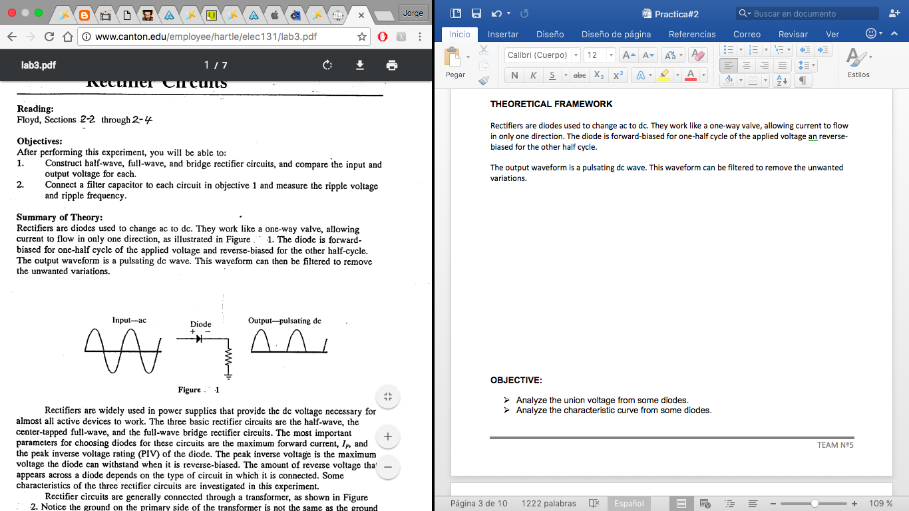

Rectifiers are widely used in power supplies that provide the dc voltage necessary for almost all active devices to work. The three basic rectifier circuits are the half-wave, the center-tapped full wave, and the full-wav bridge rectifier circuits. The most important parameters for choosing diodes for these circuits are the maximum forward current, I, and the peak inverse voltage rating (PIV) of the diode. The peak inverse voltage is the maximum voltage the diode can withstand when it is reverse-biased. The amount of reverse voltage that appears across a diode depends on the type of circuit in which it is connected. Some characteristics of the three rectifier circuits are investigated in this experiment.

# THEORICAL FRAMEWORK

**CURRENT RECTIFIER**

A rectifier is the element or circuit that converts AC to DC. This is done using rectifier diodes. Depending on the characteristics of the AC supply employing, the rectifiers are classified in single-phase, when they´re fed by an electrical network, or triple-phase, when they’re fed by three phases. By type of rectification, can be half wave, they can be half-wave type, when just one semi-cycle is being used; or full wave, where both semi-cycles are being used.

**HALF-WAVE RECTIFIER CIRCUITS**

It is built with one diode, so it could maintain the flux of current on just one direction. It may be used to convert AC into DC. When Voltage supply is positive, the diode is polarized directly, and it may be substituted for a short circuit. If the Voltage supply is negative, the diode is polarized inversely, and it may be substituted for an open circuit. Thus, when the diode is polarized directly, the Voltage Out through the charge can be found by the relation of a Voltage Divisor, we also know that the diode requires 0.7 Volts to be polarized, so Voltage Out is reduced to this value, despite the fact that it depends on the material which is made of.

When the polarization is inversely, the current is zero, therefore, the Voltage out is zero as well. This rectifier is not very efficient, because during the half of every cycle the entrance blocks itself completely from the out, losing the half of the voltage supply. The voltage out in this type of rectifier is approximately 0.45 maximum.

**FULL-WAVE RECTIFIER WITHIN TWO DIODES**

The transformer converts the AV supply into another AV with a value desired, this Voltage is rectified during the first semi-cycle bye the D1 diode and during the second semi-cycle by the D2 diode, so charge receives an impure pulsing CV, because it’s not filtered or stabilized.

**FULL-WAVE BRIDGE RECTIFIER**

It’s a full-wave rectifier in which is necessary to use one only transformer if the Voltage out must have a value distinct of the Voltage supply.

**FILTERED**

The current obtained at the out of the rectifiers it’s not properly continuous and it’s far from being acceptably constant, which unused most electronic applications.

To avoid this inconvenient, it’s necessary to use a filter to eliminate the locks in the signal. This is made by RC filters or LC, obtaining at the out a DC with a lock which depends on the filter and the charge, so without any charge, there’s no lock.

# OBJECTIVE:

* Analyze the function of the different rectifiers with diodes
* Analyze the behavior of the different rectifiers with filter of integrations
* Interpret the obtained values and to compare them with the theoretical values

## MATERIALS

* 1 Slat of experimentation (protoboard)
* 4 Diodes 1N4003
* 1 Transformer de 12V a 1ª with central derivation
* 1.5 Meters of duplex cable of No. 14
* 1 Peg

## EQUIPMENT

* Multimeter
* Oscilloscope of general intention
* 2 Tops BNC-cayman for oscilloscope
* Transformador
* 1 Tape of isolating
* 1 Resistance of 100 Ohms a 10 W
* 1 Resistance of 22 Ohms a 25W
* Electrolytic Capacitor of 470 mf a 50 v
* Electrolytic Capacitor of 2200 mf a 50 V
* 6 Tops cayman - cayman
* 1 Game of tops of multimeter
* 1 Power connector

# EXPERIMENTAL DEVELOPMENT

# Transformer

Arm the following circuit

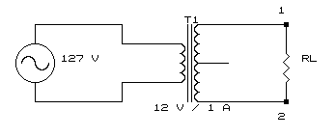

* Places a resistance of load according to the table and measure with the voltage in the terminuses 1 and 2 of the circuit in the option CA

|  |  |
| --- | --- |
| RL | Vms |
| 100 Ohms | 14.23 V |
| 22 Ohms | 13.24 V |

# Rectifier of half a wave

Arm the following circuit

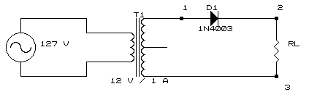

Place a resistance of load (RL) of 100 Ohms

The voltage measures to the exit of the transformer (Vt) in the option CA of the multimeter in the terminuses 1y 3 of the circuit and later the voltage of the resistance of load (V0) in the option CD of the multimeter in the terminuses 2 and 3

**VT= 14.80 V. V0=6.36 V Calculate I0= 63.6mA**

Later the channel places 1 of the oscilloscope in the terminuses 1 and 3, and the channel 2 in the points 2 and 3, and draw the signs at the entry and the exit of the rectifier. Both channels must be in the option of CD.

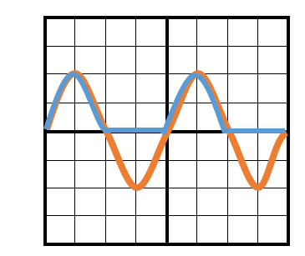

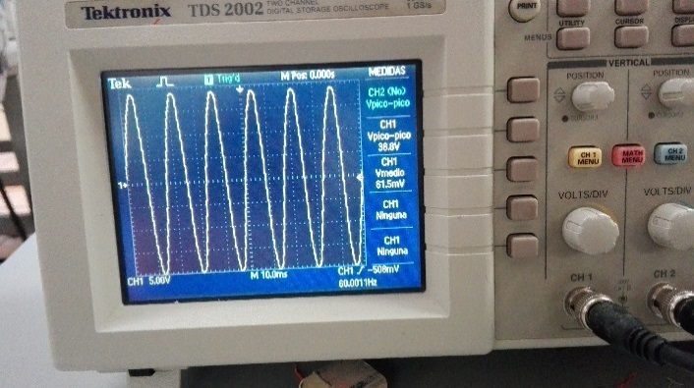

**5 V/div canal1**

**5 V/div canal 2**

**10mseg/div**

The voltage obtains beak of the transformer of the sign of the channel 1

**Vp= 19.4 V**

To obtain the voltage I puncture less the voltage of the diode of the channel 2

**Vp-Vd= 19.4V**

# Rectifier of half a wave with filter of integration

Arm the following circuit:

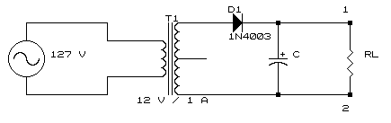

Place a resistance of load of 100 ohms and the capacitor according to the table

Measures the voltage of the resistance of load (Vo) in the option CD of the multimeter in the terminuses 1 and 2, and calculate the current of exit (Io)

Later the channel places 1 of the oscilloscope in the terminuses 1 and 2 in AC's option and measure the voltage of curl of the rectifier (*V0)

|  |  |  |  |
| --- | --- | --- | --- |
| Capacitor | V0 | I0 | V0 |
| 470mf | 16.06V | 160.6mA | 1.42V |
| 2200mf | 16.63V | 166.3mA | 30mV |

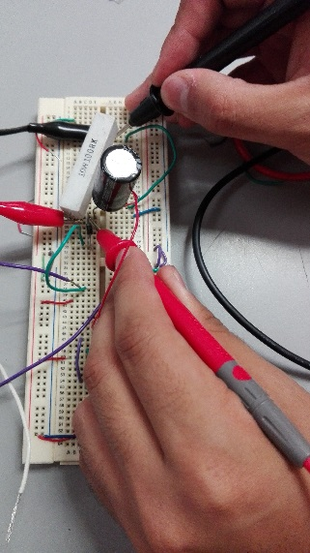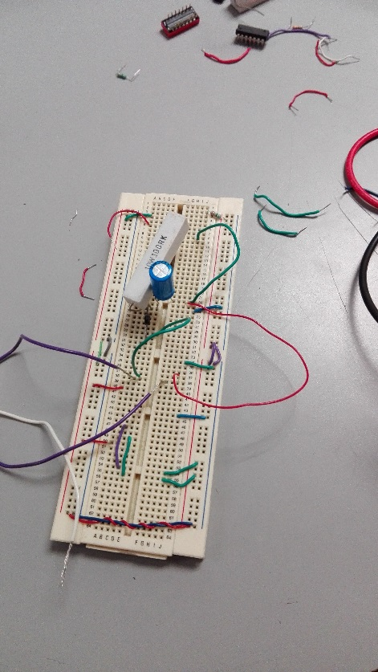

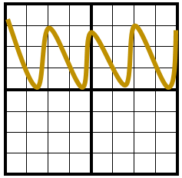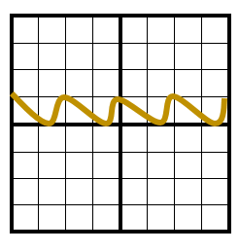**The channel draws 1 with the capacitor of 470 mF The channel to draw 1 with the capacitor of 2200mF**

**500 mV/div canal1**

**10 mseg/div**

**2 V/div Canal 1**

**10 mseg/div**

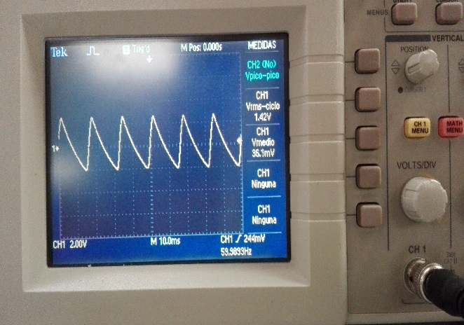

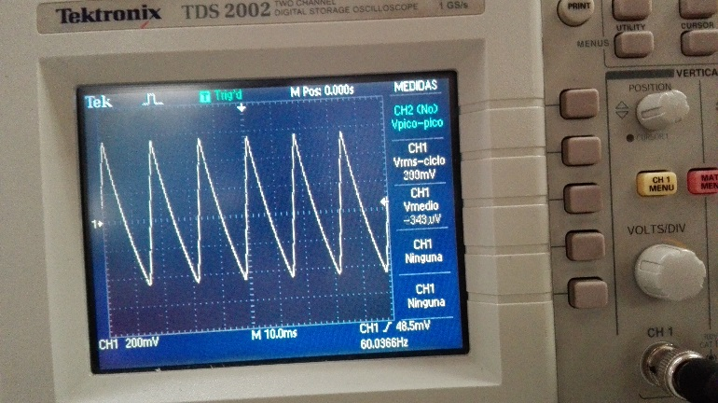

# Wave rectifier completes with two diodes

Arm the following circuit

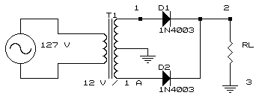

Place a resistance of load (Rl) of 100 ohms

The voltage measures to the exit of the transformer (Vt) in the option CA of the multimeter in the terminuses1y 3 of the circuit and later the voltage of the resistance of load (V0) in the option of CD of the multimeter in the terminuses 2 and 3

**Vt= 14.8 V, V0= 5.8 Calculate I0=58.0mA**

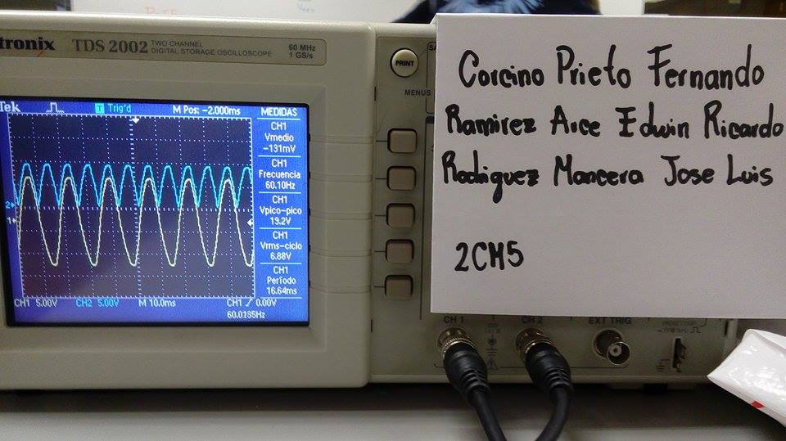Later the channel places 1 of the oscilloscope in the terminuses 1 and 3, and the channel 2 in the points 2 and 3, and draw the signs that are obtained at the entry and exit of the rectifier. Both channels must be in the option of CD.

**5 V/div canal 1**

**5 V/div canal 2**

**10 mseg/div**

The voltage obtains beak of the transformer of the sign of the channel 1

**Vp= 10.3 V**

To obtain the voltage I puncture less the voltage of the diode of the channel 2

**Vp/2- Vd= 4.45**

# Wave rectifier completes with two filters of integration

Arm the following circuit

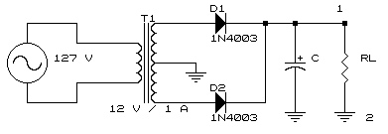

Place a resistance of load of 100 ohms and the capacitor according to the table

There measures the voltage of the resistance of load (V0) in the option CD of the multimeter in the terminuses 1 and 2, and calculate the current of exit (I0)

Later the channel places 1 of the oscilloscope in the terminuses 1 and 2 in AC's option and measure the voltage of curl of the rectifier (¨ *V0)

|  |  |  |  |
| --- | --- | --- | --- |
| Capacitor | Vo | Io | Vo |
| 470 mF | 8.7 V | 87mA | 358mV |
| 2200mF | 8.9V | 89mA | 74.7mV |

To draw the channel with capacitor of 470mF The channel to draw 1 with capacitor of 2200mF

# Wave rectifier completes type bridge

Arm the following circuit

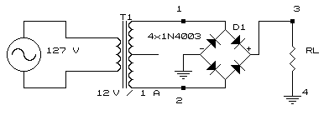

Place a resistance of load (Rl) of 100 ohms

The voltage measures to the exit of the transformer (Vt) in the option CA of the multimeter in the terminuses 1 and 2 of the circuit and later the voltage of the resistance of load (v0) in the option CD of the multimeter in the terminuses 3 and 4

**VT = 8.3 V Vo= 5.6V Calculate I0=56mA**

The channel places 1 of the oscilloscope in the terminuses 1 and 2, and draw the sign that is obtained, later the channel disconnects 1 The channel places 1 of the oscilloscope in the terminuses 1 and 2, and draw the sign that is obtained, later the channel disconnects 1

**It notices: not to connect both channels of the oscilloscope at the same time in this circuit, due to the fact that the short one will be generated.**

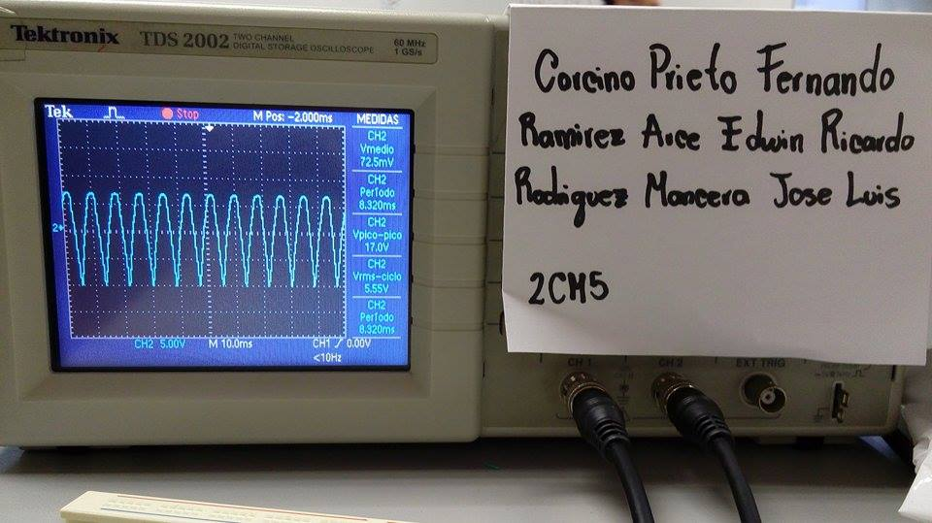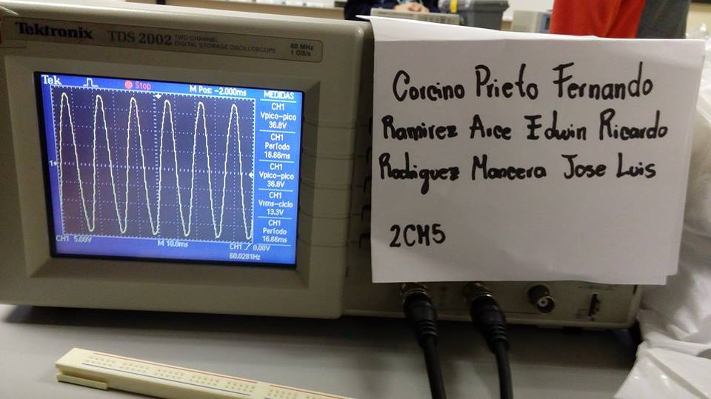

The voltage obtains beak of the transformer of the sign of the channel 1

VP = 18.4 V

To obtain the voltage puncture less the voltage of the diode of the channel 2

Vp-2VD= 17 V

# Wave rectifier completes type bridge with filter of integration

Arm the following circuit

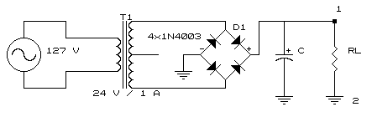

Place a resistance of load of 100 ohms and the capacitor according to the table

There measures the voltage of the resistance of load (V0) in the option of CD of the multímetro in the terminuses 1 and 2 and calculate the current of exit (I0)

Later the channel places 1 of the oscilloscope in the terminuses 1 y2 in the option AC and measure the voltage of curl of the rectifier (*V0)

|  |  |  |  |
| --- | --- | --- | --- |
| Capacitor | V0 | Io | V0 |
| 470mF | 16.6 | 166mA | 6.48mV |
| 2200mF | 16.7 | 167mA | 154mV |

**The channel draws 1 with the capacitor of 470 mF The channel to draw 1 with capacitor of 22000mf**

# THEORETICAL ANALYSIS

To realize the theoretical analysis of all the previous circuits

1. Transformer

|  |  |
| --- | --- |
| RL | Vms |
| 100 Ohms | 14.23 V |
| 22 Ohms | 13.24 V |

Of here is outlined Ohm's Law, which does not say V=RI, for which one checks that to major resistance voltage and to minor resistance proportionate voltage.

1. Rectifier of Half a Wave Without Filter

|  |  |  |
| --- | --- | --- |
|  | Medido | Calculado |
| VO | 5.65 V | 5.39 V |
| IO | 56.5 mA | 53.9 mA |
| VP | 17.6 V | 17 V |
| VP-VD | 16.9 V | 16.3 |

The variations in the measures owe to themselves to which due to the manufacture of the Transformer and other agents extra a variation of results happens

1. Rectifier of Half a Wave with filter

|  |  |  |
| --- | --- | --- |
| 470 µF | Medido | Calculado |
| VO | 14.29 V | 13.98 V |
| IO | 142.9 mA | 139.8 mA |
| ∆VO | 2.4 V | 2.13 V |

|  |  |  |
| --- | --- | --- |
| 2200 µF | Medido | Calculado |
| VO | 14.62 V | 16.35 V |
| IO | 146.2 mA | 163.5 mA |
| ∆VO | 620 mV | 455.3 mV |

A rectifier provides a constant sign to us since the transformer provides to us an exit of alternate sign this component takes charge rectifying it, nevertheless if we want a much more faithful sign, is for it that we use an electronic component named Capacitor

1. Wave rectifier Completes with Two Diodes

|  |  |  |
| --- | --- | --- |
|  | Medido | Calculado |
| VO | 5.32 V | 5.39 V |
| IO | 53.2 mA | 53.9 mA |
| VP | 9.6 V | 8.48 V |
| VP-VD | 8.9 V | 7.78 |

Since we have followed it commenting, variations exist in the information due to the conditions of the components, a value calculated in general does not come closer with the measured one.

1. Wave rectifier Completes with Two Diodes with Filter

|  |  |  |
| --- | --- | --- |
| 470 µF | Medido | Calculado |
| VO | 7.88 V | 7.72 V |
| IO | 78 mA | 77.2 mA |
| ∆VO | 3.24 V | 531.5 mV |

|  |  |  |
| --- | --- | --- |
| 2200 µF | Medido | Calculado |
| VO | 8 V | 8.31 V |
| IO | 80 mA | 83.1 mA |
| ∆VO | 19.4 mV | 113.56 mV |

1. Wave rectifier Type Bridge

|  |  |  |
| --- | --- | --- |
|  | Medido | Calculado |
| VO | 10.4 V | 10.81 V |
| IO | 104 mA | 108 mA |
| VP | 18.4 V | 17 V |
| VP-VD | 17 v | 16.3 |

1. R**ectificador de Onda Tipo Puente con Filtro**

|  |  |  |
| --- | --- | --- |
| 470 µF | Medido | Calculado |
| VO | 15.1 V | 15.49 V |
| IO | 151 mA | 154.9 mA |
| ∆VO | 605 mV | 1.06 V |

|  |  |  |
| --- | --- | --- |
| 2200 µF | Medido | Calculado |
| VO | 15.28 V | 16.67 V |
| IO | 152.8 mA | 166.7 mA |
| ∆VO | 188 mV | 227.6 mV |

# COMPARISON OF THE THEORETICAL RESULTS, PRACTICS AND SIMULATED

To analyze all the values and to give an explanation of the variations or differences that exist in the values obtained in the theoretical, practical thing and simulated

# QUESTIONNAIRE

1. **Mention the importance of the voltage rectifiers?**

Are very important because they let us to transform a sinewave into a direct current and this can be use in some circuits that we can’t use a sinewave form a voltage.

1. **Explain the difference that exist between a half-wave rectifier and full-wave?**

The half-wave rectifier only rectifies a half wave just like his name indicates, what we can say is that in some periods from the frequency that the voltage is negative we doesn’t have any current, and on the other side with de full-wave rectifier we always have current.

1. **What is the difference of a full-wave rectifier with center tap and the bridge type?**

That the full-wave rectifier needs the center tap and less diodes and the bridge type needs more diodes so we can conclude that the drop tension from one more diode will represent a worst performance and maybe the price between each one.

1. **How we measure the output voltage of the rectifier?**

On his load resistor that represents the output voltage.

1. **How we measure the ripple voltage from the rectifier?**

With the help from an oscilloscope, or we can use the next formula:

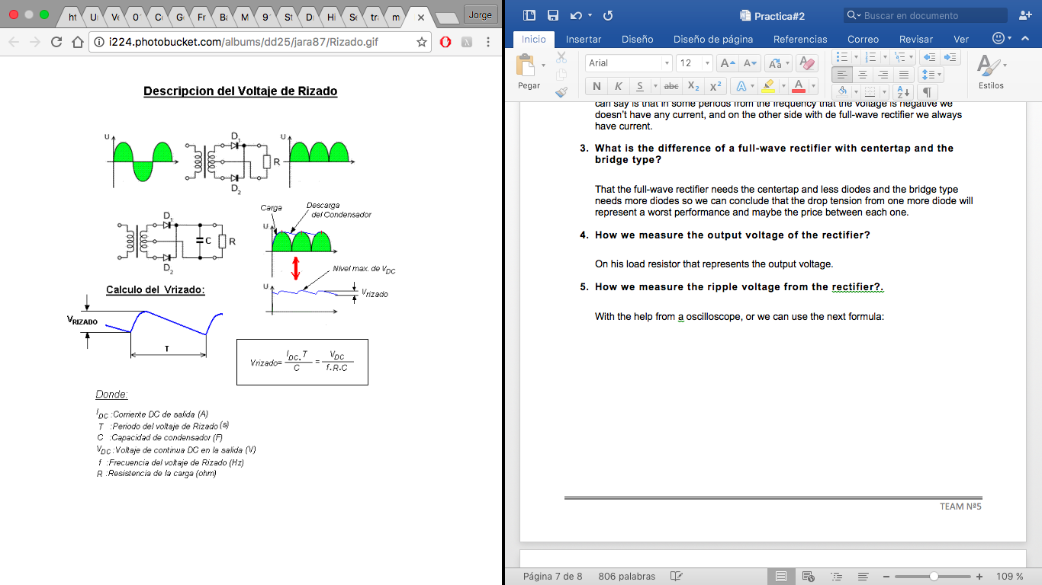

Where:

IDC: Output DC current.

T: Period of the ripple voltage.

C: Capacitance of the capacitor

VDC: Output DC voltage.

f: Frequency from the ripple voltage

R: Load Resistance

# CONCLUSIONS

**KONISHI GOVANTES JORGE AGUSTÍN**

When we compare the theoretical, experimental and simulated analysis I can note in a better way the behavior from the different rectifiers.

The rectifiers that doesn’t have any integer filter, I can note how the sinewave from the transformer, is giving only rectified direct current, but nevertheless we can note how the ripple voltage is high in the different rectifiers, but when we used the integer filter, the ripple voltage down, and while the capacitance from the capacitor is more the ripple voltage downs even more, thus allowing better rectification from the wave to reach the continues current.

**LUCIANO ESPINA MELISA**

With it is practical I could realize since a transformer it gives the wave that we saw in the class, this way since each of the stages could be visualized by help of the oscilloscope of rectification of a wave, so much with two, diodes four diodes, and both different capacitors Some measures changed, but this was for the voltage that was giving us the transformer that was more of 12V but it was equivalent to the proportionate measures.

**MENA ORTIZ ERICK JAFET**

The practice has allowed us to view and analyze the different types of rectifiers and the behavior witch which they operate along with the capacitors and how they affect the transformer’s voltage, applied from a stages series.

We could check the different signals generated, as well as a comparison analysis of the results obtained in the practice, and the ones obtained in the calculations, in which we could found similitudes.

Also, thanks to the oscilloscope, we could check the theoretical values obtained in the class, as well as observe the way the wave changes along the rectifier and capacitor.